**Skeleton of java program**

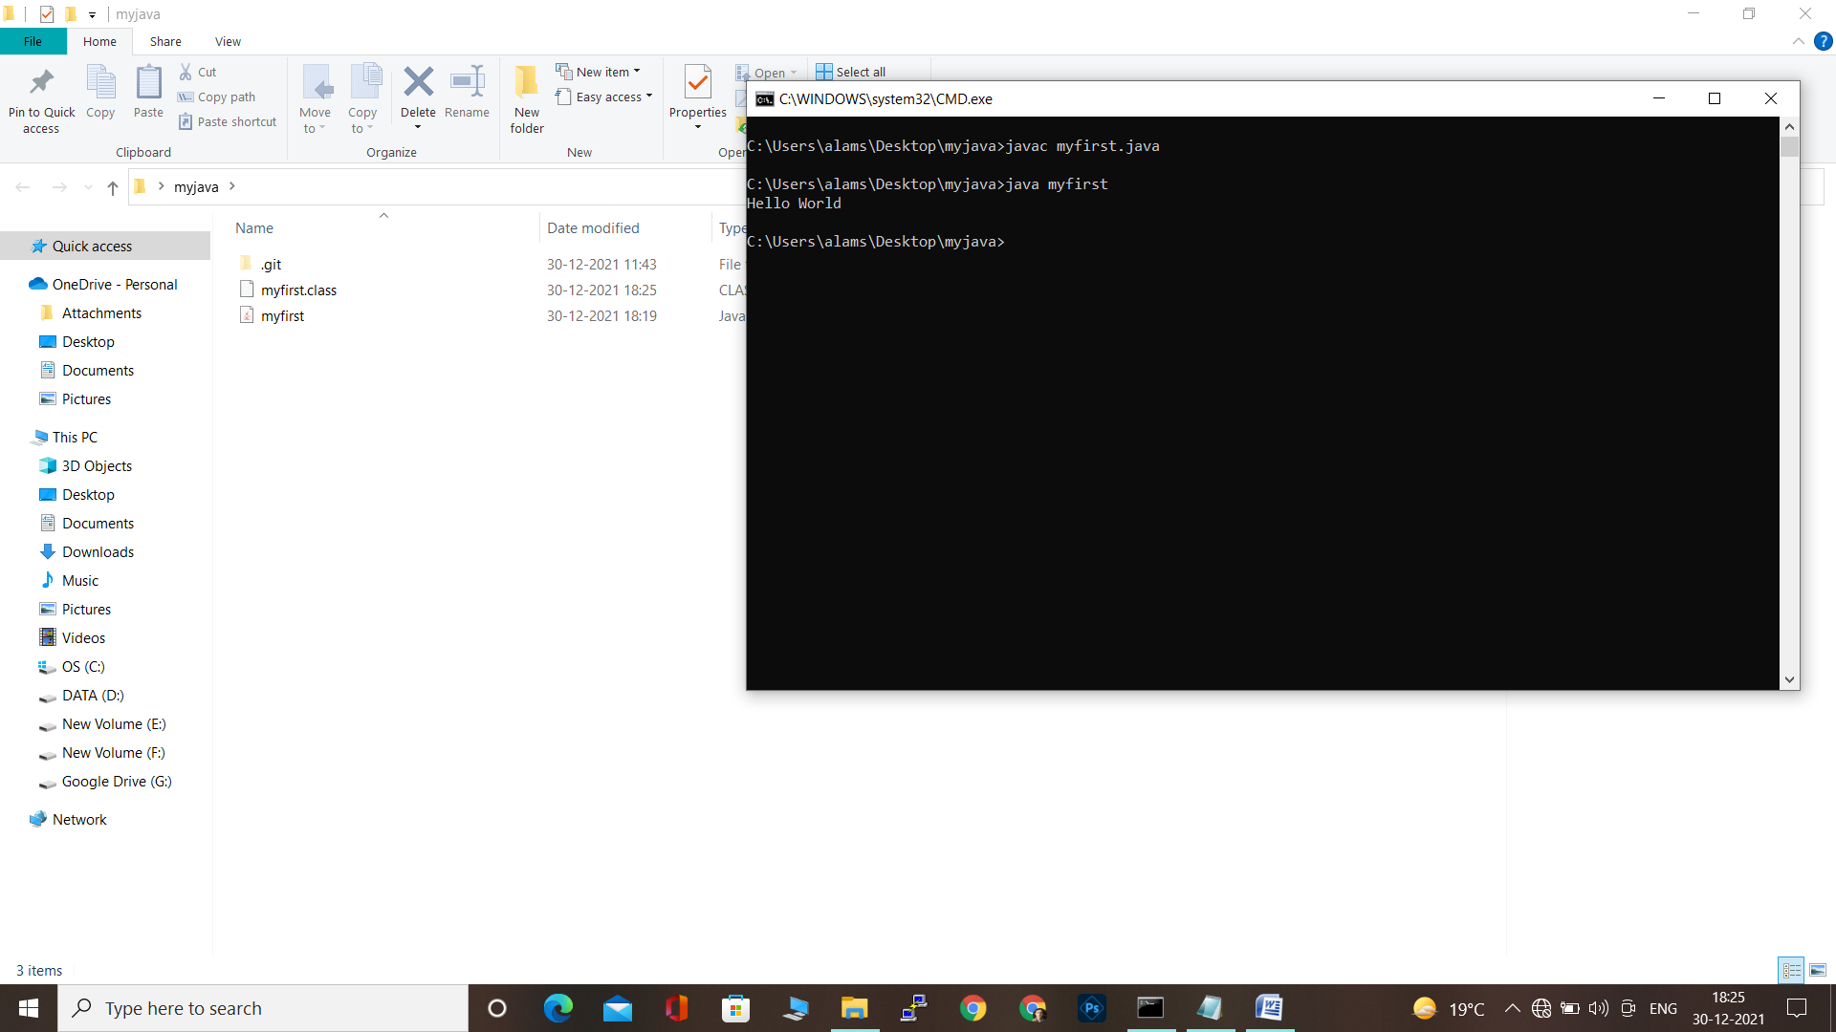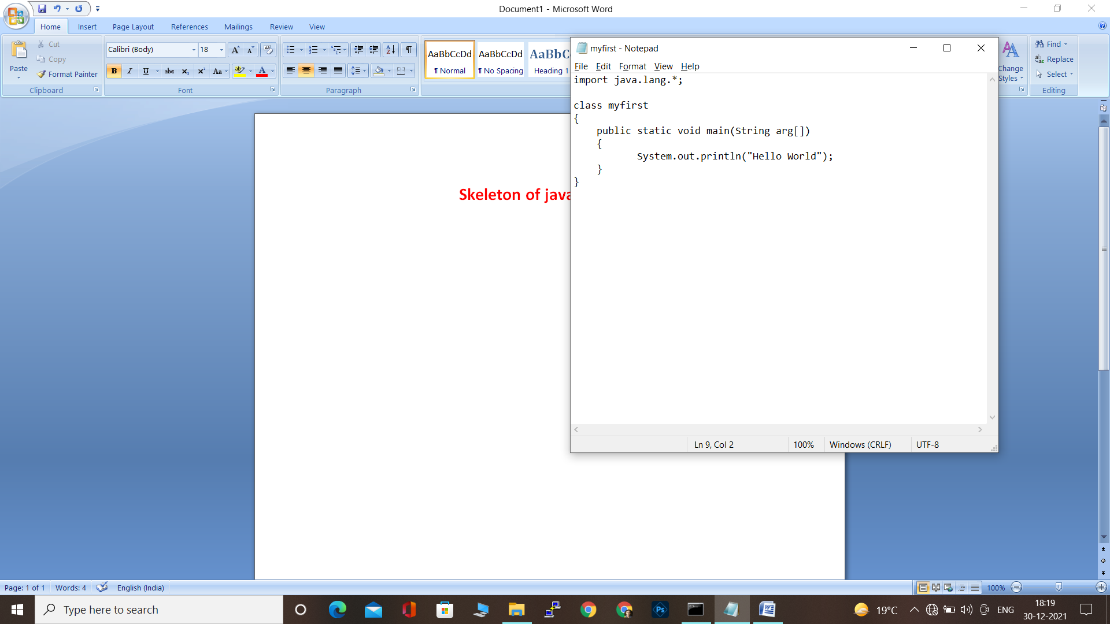

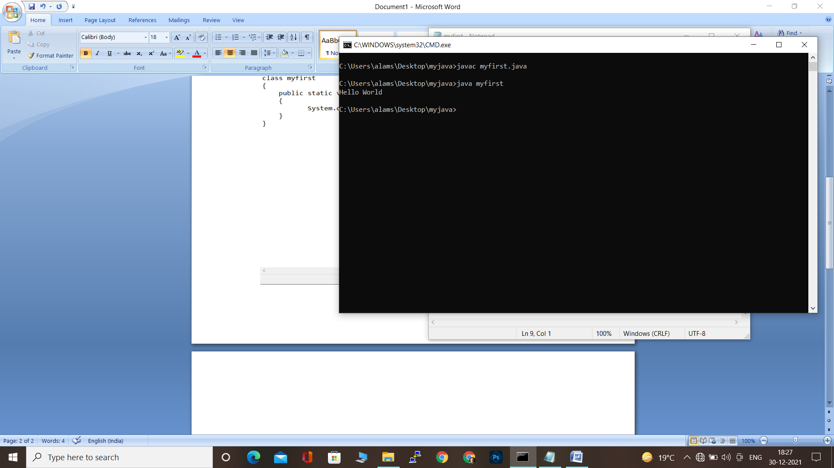

**When we write public keyword in class then the name of the file must be in the name of class thats why we have chosen class name as file name so that error will not occur.**

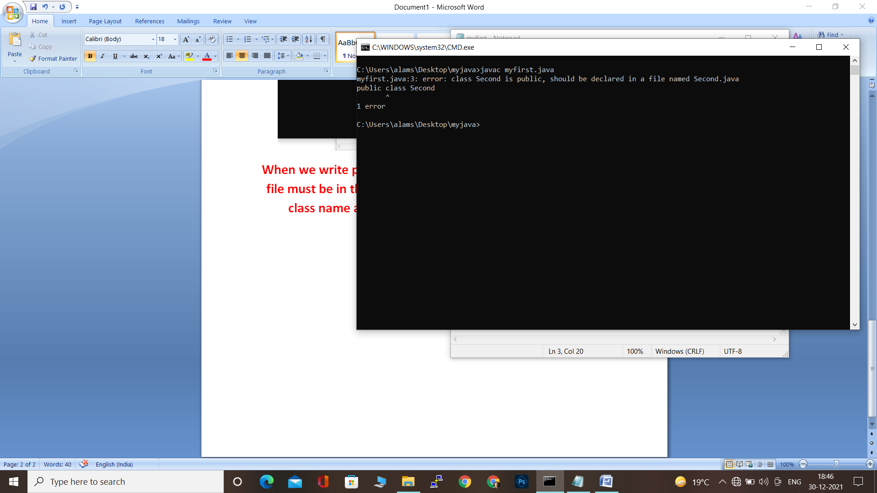

**We cannot remove String arg[]-which is command line argument because thats the syntax of java without it it will not run but it will compile without error.**

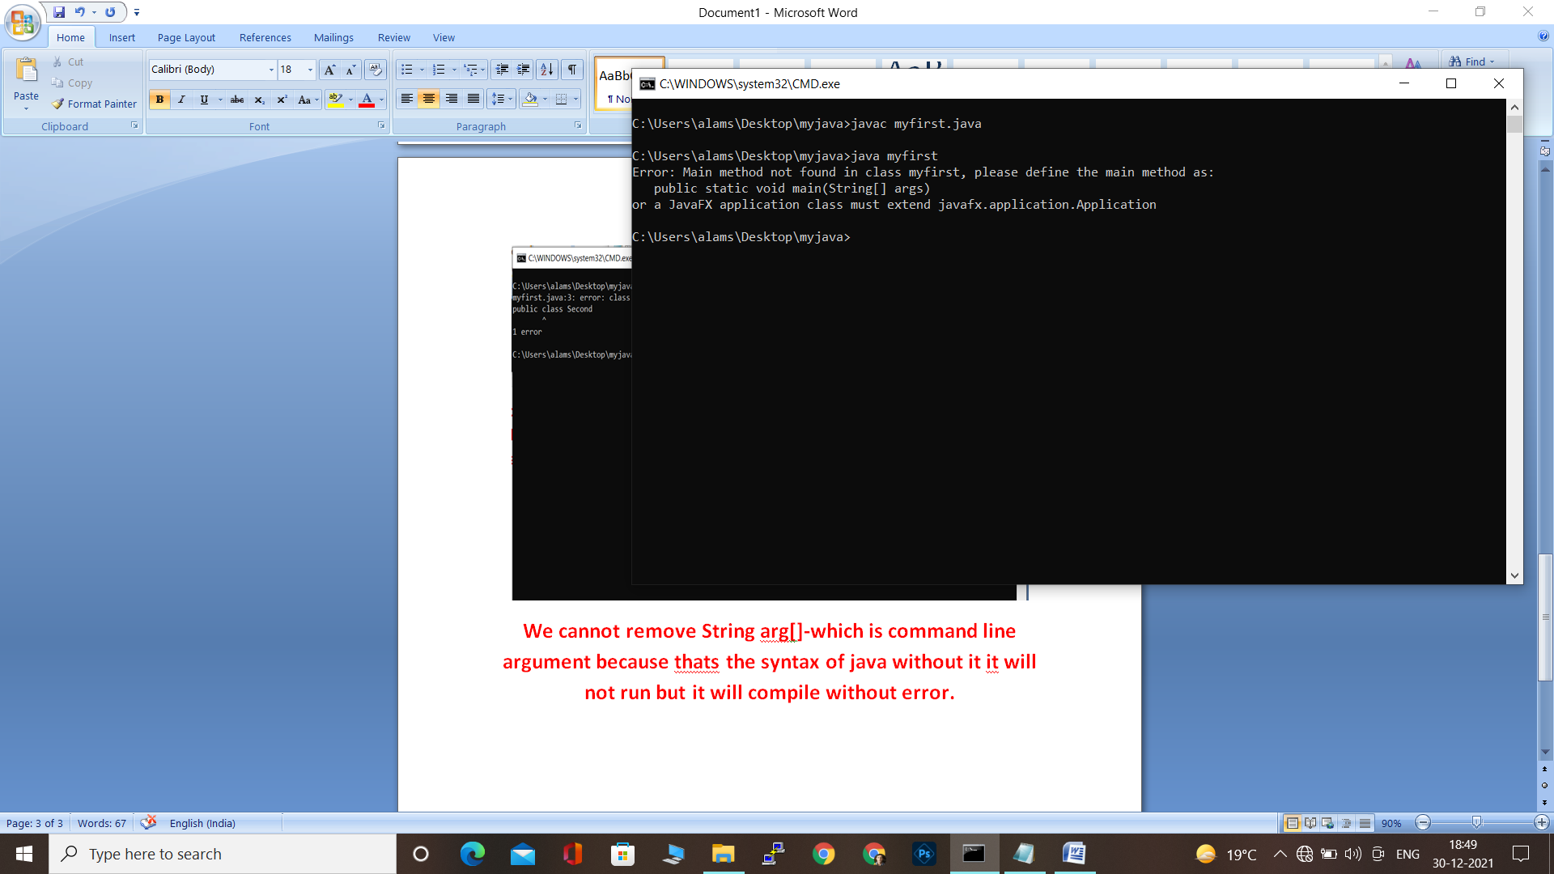

**We can write command line argument as well which is given by the command line**

**In this way we can the command line arguments**

